Setup & Firmware Uploading Guide
Smart Button

Assembly Guide

- Prepare the Board for programming by connecting it to Voltlink programmer
Use the connection cable provided with the Voltlink adapter to connect with the Voltlink connector marked in the Board
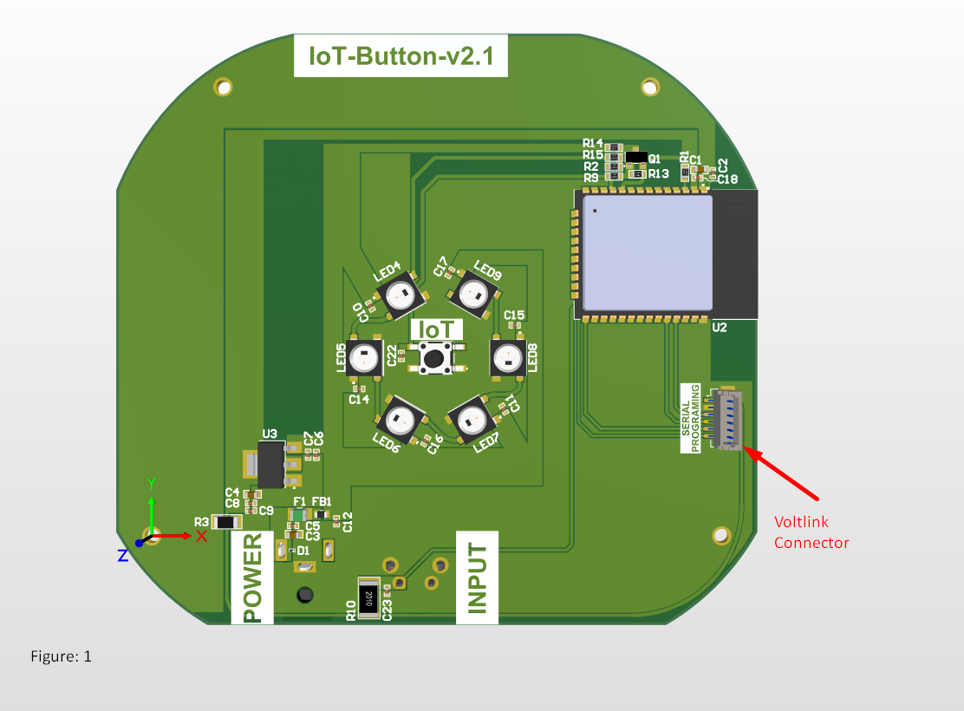

Set up the firmware upload and development environment:

Step 1. Set up Arduino IDE
Arduino IDE can be downloaded from the Arduino website: https://www.arduino.cc/en/Main/Software
When the installation is finished, open Arduino IDE. Go to “File” -> “Preferences”.
And paste the following URL into the “Additional Boards Manager URLs” field:
https://raw.githubusercontent.com/espressif/arduino-esp32/gh-pages/package_esp32_index.json
Step 2. Set up Arduino IDE for ESP32
Next, go to “Tools” -> “Board” -> “Boards Manager”: and search for ESP32 install the one by “Espressif systems” as shown in image below
The “Boards Manager” requires several seconds to refresh all hardware files
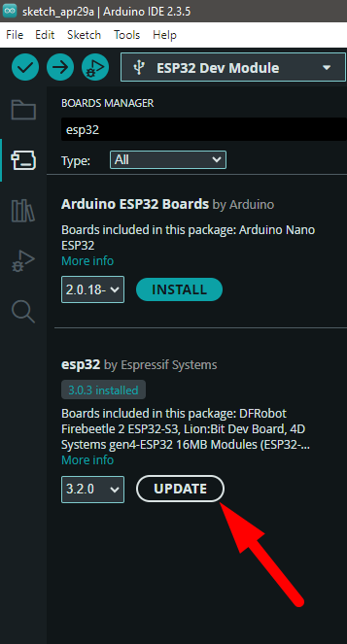

Now, go to “Tools” -> “Board” -> “esp32” ->Select ESP 32 Dev Module
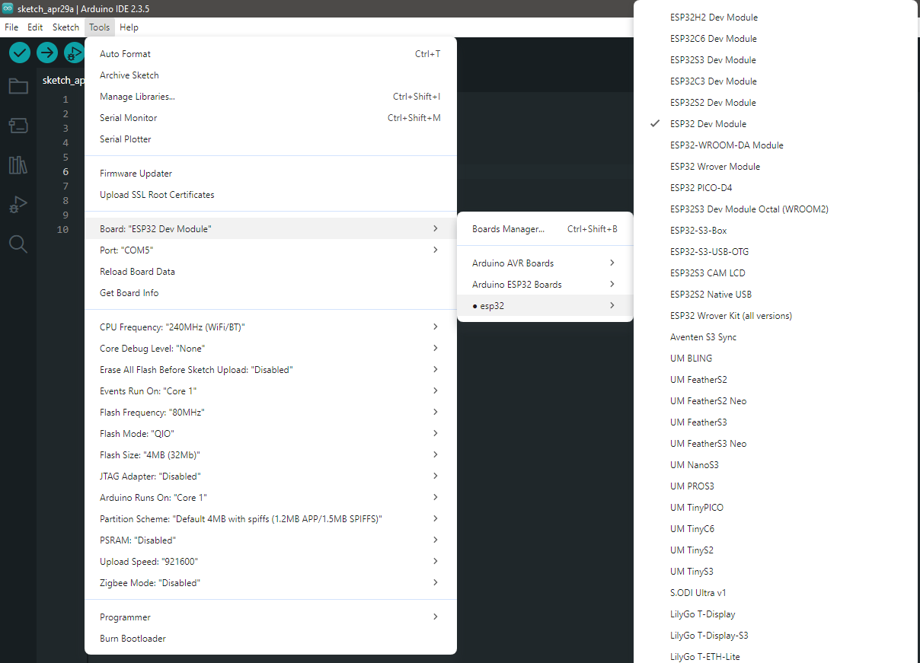

Step 3. Install the Serial port:
Make sure the Voltlink-board is connected to computer via Type-C USB.
After connected, the USB driver will be automatically installed. If there is any driver issue of connecting board, please go to CP210x USB to UART Bridge VCP Drivers - Silicon Labs for USB driver. Check the COM Port number in Device Manager for Windows OS user:
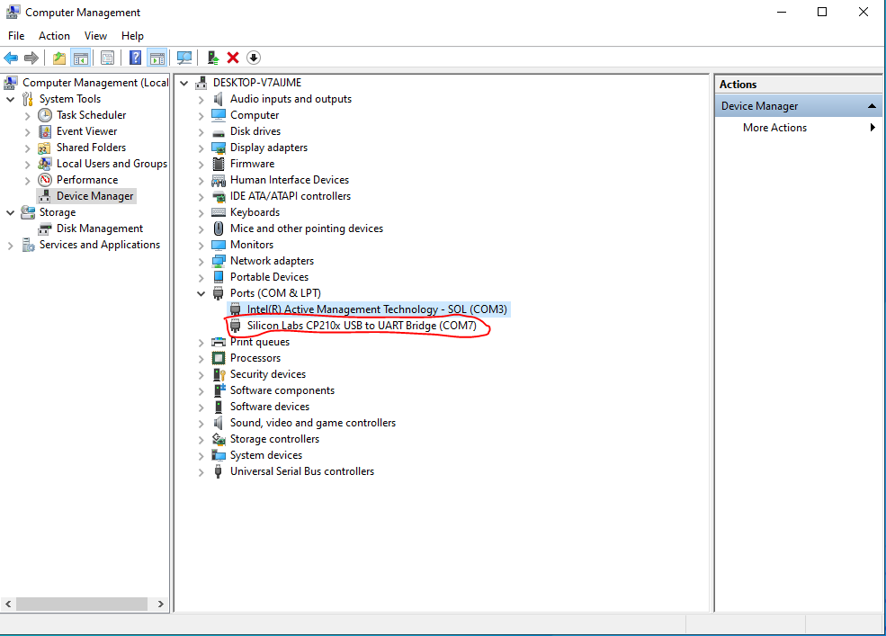
Now open the latest provided firmware
Next go to “Tools” -> “Port” and select the correct COM port.
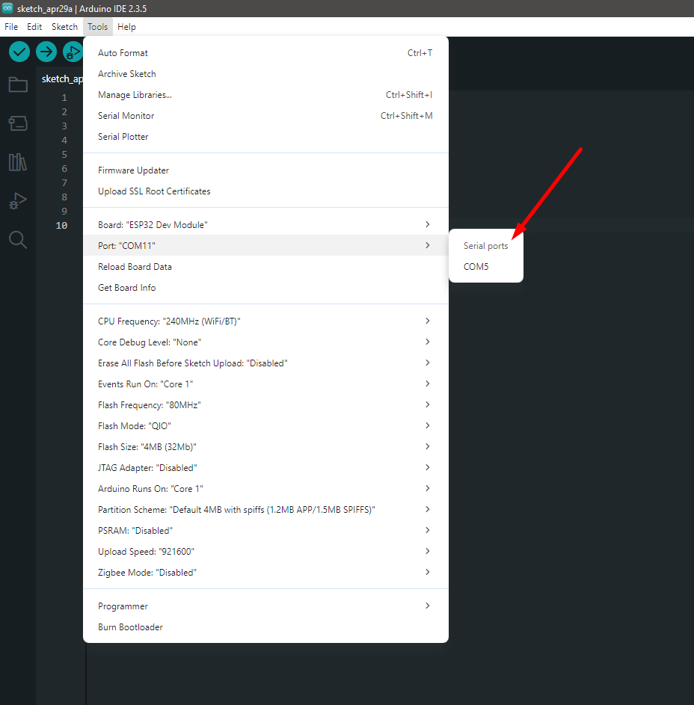
After selecting the correct COM port upload the code by pressing the upload button as mentioned below
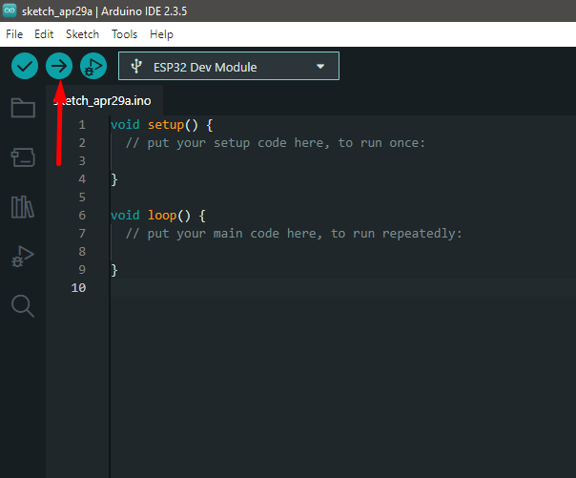

Hardware Testing Guide:

